Social Fundraising for Fundraisers

A fundraiser’s reference for using Social Fundraising in NeonCRM by Z2 Systems, Inc.

Contents
Social Fundraising for Fundraisers 1
Option 1: Login using an Existing Account 3
Option 2: Create a New Account 4
Creating a NeonCRM Account: 4
Creating an account using Facebook 8
Creating an account with Twitter 9
Creating a Fundraising Page 11
Managing Your Fundraising Page 12
Page Content Tab 15
Share My Page Tab 16
Donations Tab 17
Event Registrations Tab 17
Comments Tab 18
Team Tab 18

For the purposes of this guide, we assume that you have been given a link to an existing Social Fundraising page, or you have received an email asking you to create a fundraising page. If you need help finding this link, please contact the organization for which you are fundraising.

Option 1: Login using an Existing Account
If you have interacted with this organization before (e.g. made a donation, registered for an event, or purchased a membership) you may already have an account. If you have logged into your account before and know your Login Name and Password, you can enter it here and begin setting up your Fundraising Page. If you are unsure whether you have an account or not, you can click the “Get help” text for assistance recovering your account information.

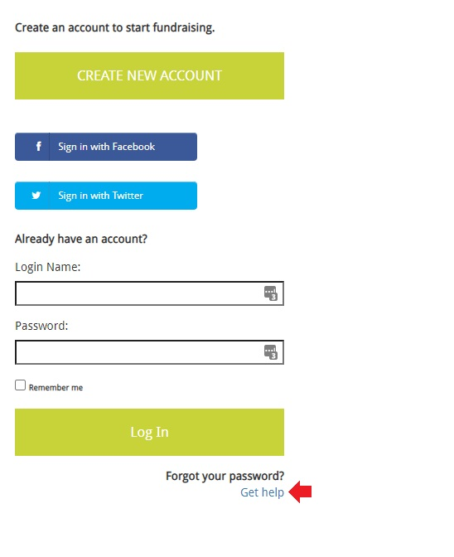

Option 2: Create a New Account
In order to start fundraising, you need to create an account. You can either click the “Create New Account” button, or you can use an existing Facebook or Twitter account to log in instead.

Creating a NeonCRM Account:
Begin by clicking Create New Account.
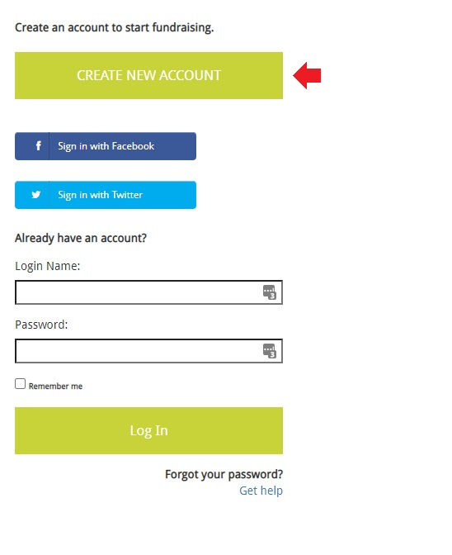
Enter your First Name, Last Name, and Email.
Click Submit when finished.
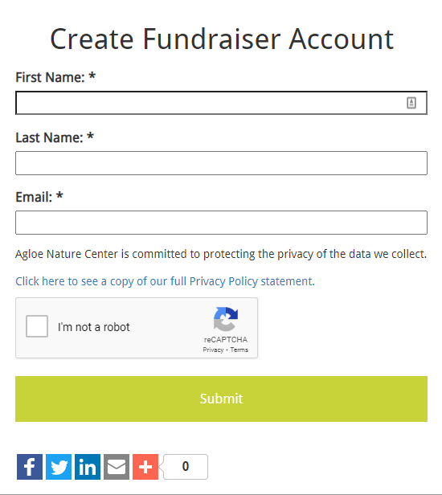

You will see a message saying “Thank you for submitting your information!” confirming your submission.
Your next step will be to check your email inbox. You will receive an email with a link prompting you to choose your login name and password.
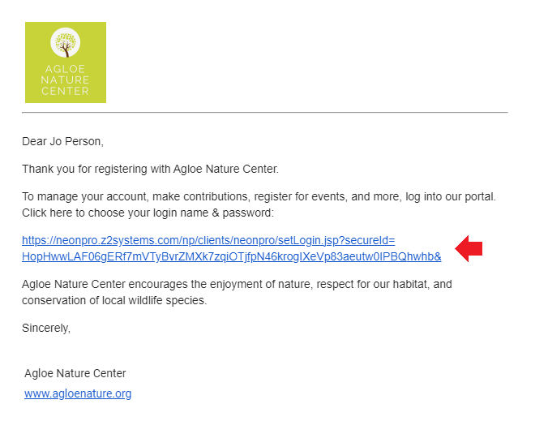
Once you click that link, you will be taken to a page to establish a Login Name and Password:
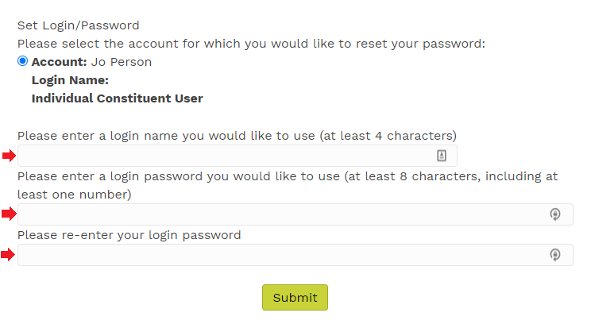

Now that you have created your Login credentials, you can go back to the Social Fundraising link you have been given by your organization and login to start setting up your fundraising page.
Once logged in, it is a good idea to bookmark this page so you can easily find your fundraising page later. Skip to page 11 of this guide for next steps.

Creating an account using Facebook
Instead of creating a new login name and password, you can use your existing Facebook account to sign in.
Click the Sign in with Facebook button.
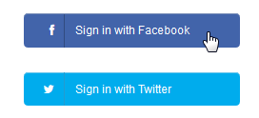
A pop-up window will appear. Ensure that your web browser is not blocking pop-ups on this page.
Enter your Facebook user name and password. Click Log In.
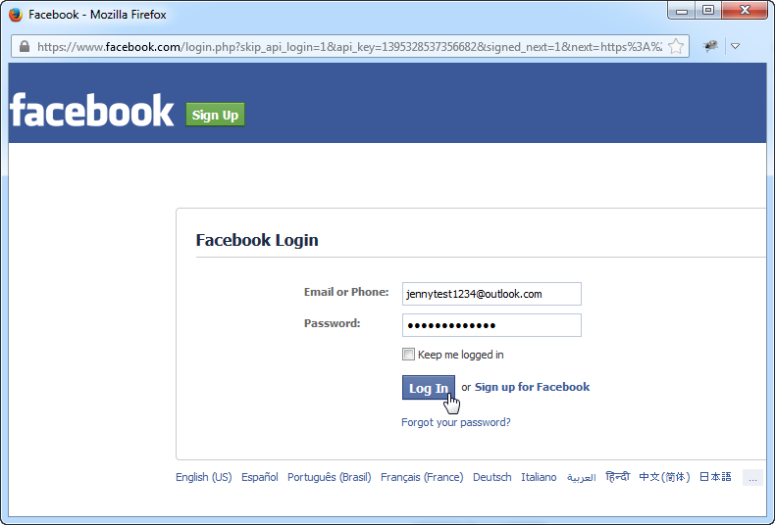

Click Okay on the next page.
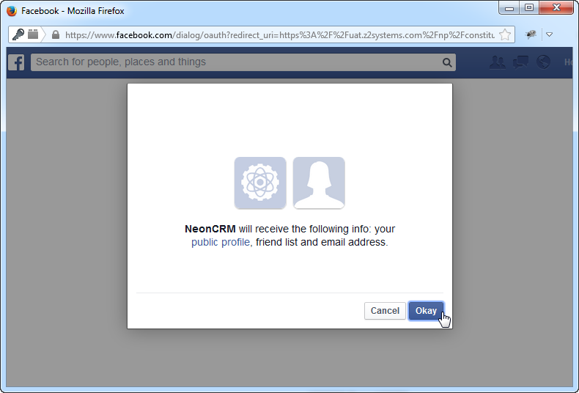
Once you have logged in, you will be taken to the Constituent Login Portal homepage. It’s a good idea to bookmark this page so you can easily find your fundraising page later. Skip to page 11 of this guide for next steps.

Creating an account with Twitter
Click the Sign in with Twitter button.
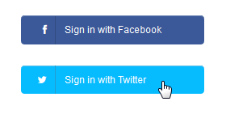
Enter your Twitter user name and password and click Sign In.
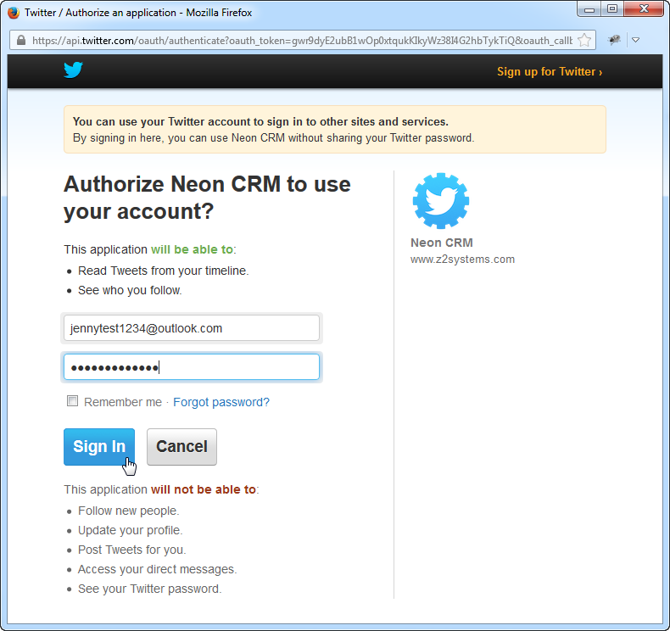
Once you have logged in, you will be taken to the Constituent Login Portal homepage. It’s a good idea to bookmark this page so you can easily find your fundraising page later. Continue to the following section for next steps.

Creating a Fundraising Page
Once you have logged in through the social fundraising link given to you by your organization, you will be taken to your fundraising management page.
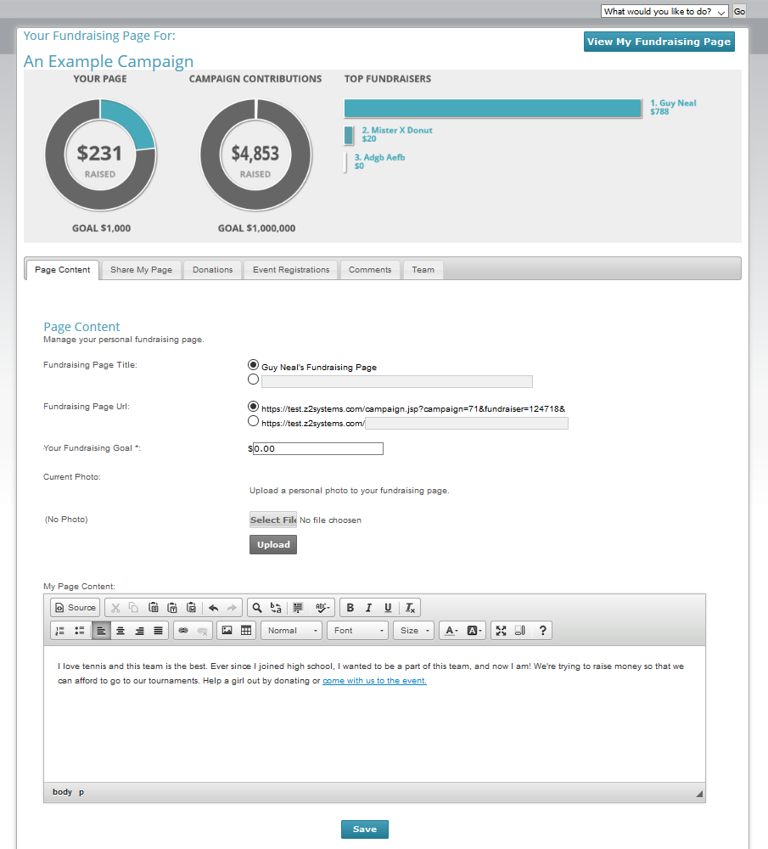

Managing Your Fundraising Page
The drop-down menu in the upper-right corner of the screen allows you to navigate to other pages provided by the organization. You may be able to access information about your own donations, update your personal contact information, or access membership information.
The View My Fundraising Page button in the upper-left corner of the screen opens your live fundraising page in a new browser tab. You can click this any time to see what your fundraising page looks like.
The charts on this page show your fundraising page’s progress toward your fundraising goal, as well as the overall progress towards the campaign’s goal. It also shows you a list of top fundraising pages for this campaign.
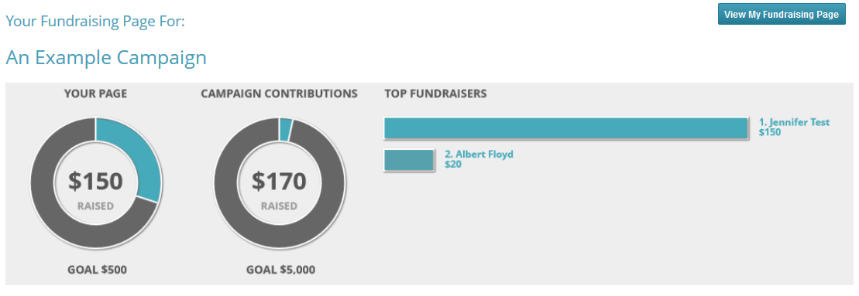

You can use the navigation bar below the charts to navigate through the features provided to help your fundraising efforts.
- Page Content – Edit the text and images that appear on your fundraising page.
- Share My Page – This helps you get the word out to your friends about your fundraising page through social media.
- Donations – This is a list of all of the donations that you have received.
- Event Registrations – This is a list of all the people who have signed up for a related event and credited you for their sign-up. You’ll only use this if your campaign has an event associated with it.
- Comments – When your donors make a donation, they can leave a comment. Use this page to hide any comments that you don’t want displayed on your page.
- Team – If teams are enabled for this campaign, you can choose to join a team or create your own in this tab.
The Back to Fundraising Page List button immediately above the charts will take you back to the Social Fundraising Overview.
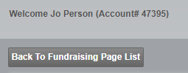

If you have more than one fundraising page, they will be listed here. Clicking the Manage Page link takes you back to your fundraising management page. If you click Deactivate, your fundraising page will no longer be visible to the public. Nobody will be able to access your page or make donations. Your data will not be deleted, and you can easily re-activate the page from this screen.
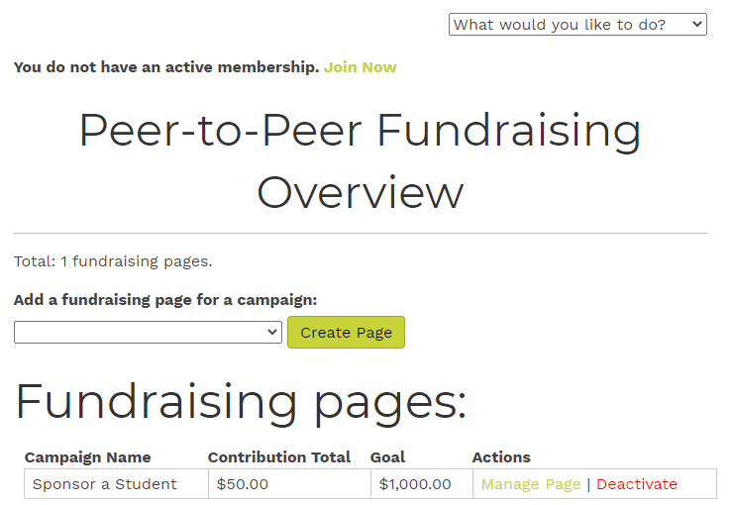

Page Content Tab
It’s a good idea to specify a fundraising goal. This goal will show up on your fundraising page. You’ll see a progress bar that shows you your progress.
You should also upload a personal photo. This will appear on both your fundraising page and the fundraiser listing page (All Fundraisers).
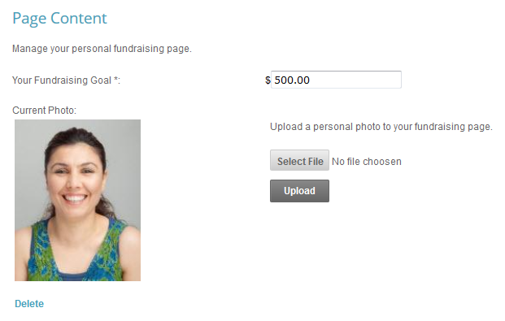
Adding personal content is a great way to tell your supporters about your fundraising efforts. Use this content editor, which works similarly to Microsoft Word, to add text and images to your fundraising page. Be sure to click Save to save your changes.
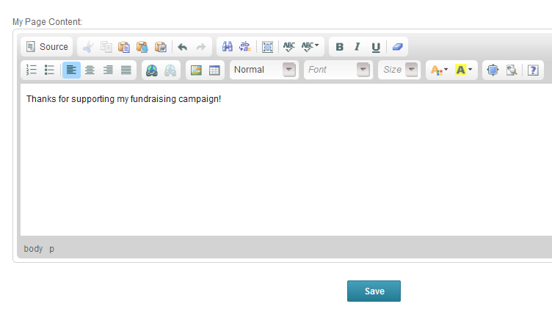

Share My Page Tab
The Share My Page tab gives you tools for sharing your fundraising page with your personal networks. You can copy and paste the direct link for use on web pages and sharing through emails.
Use the Social Media links to use your existing social media accounts to share your fundraising page with your personal networks.
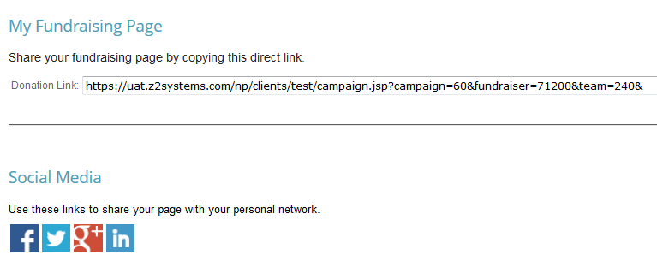

Donations Tab
The Donations tab displays a list of all donations that have been credited to you. This includes the name of the donor, the donation amount, the date they donated, and any comments they left. These donations may have either come through your donation page or have been added manually by a staff member of the organization for which you are fundraising.
Click the Export to CSV button to export this list to a .CSV file. You can open this file in a spreadsheet program such as Microsoft Excel.
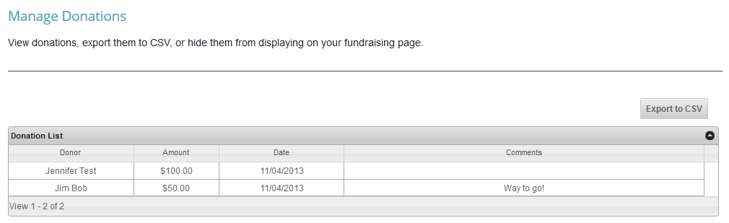

Event Registrations Tab
The Event Registrations tab displays a list of all event registrations that have been credited to you. You will only see data on this page if the organization for which you are fundraising has created a corresponding event for your campaign. It is entirely possible that you will see nothing here.

Comments Tab
The Comments Tab allows you to manage the comments on your fundraising page. You can turn comments completely off by clicking the large On/Off button. This does not delete any existing comments, nor does it prevent people from adding new comments when they donate. It merely prevents them from displaying on your page. You will still be able to see all comments on this page.
You can also hide individual comments by clicking the Hide button next to the specific comment.
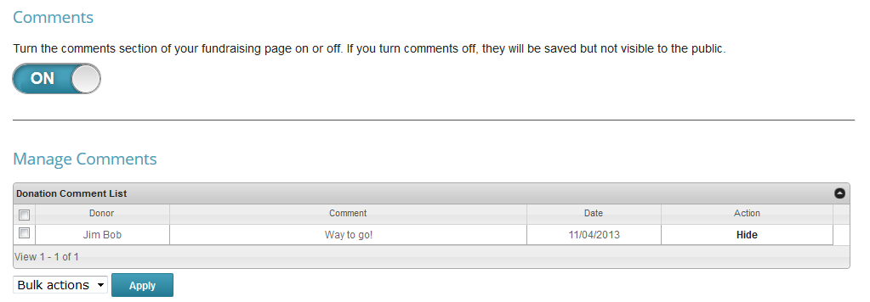

Team Tab
If you would like to fundraise as part of a group, you can join a team in this tab. Your options are:
- No thanks, I’m fundraising on my own – This will keep you unaffiliated from any team.
- Yes, and I’m team captain – This will prompt you to create a team page with its own title and content separate from your individual page.
- I’d like to join a team. – This will list all other teams currently available for you to join.
If you are team captain, you are in charge of adding content to your team page. Be sure to add a compelling story that inspires others to give to your campaign. Team pages themselves do not accept donations. Instead, visitors will be encouraged to donate to you and your teammates’ individual pages.
